

**CLOUD COMPUTING**

**BSE ( V-B )**

Submitted By:

Musfira Farooq

Roll No:

2023-BSE-045

**ASSIGNMENT 01**

**Git, Gitea, GitHub, LFS, and GitHub Pages**

**TASK 01**

**Run Gitea in Codespace and Create an Initial Repo**

* **Connecting to port:**

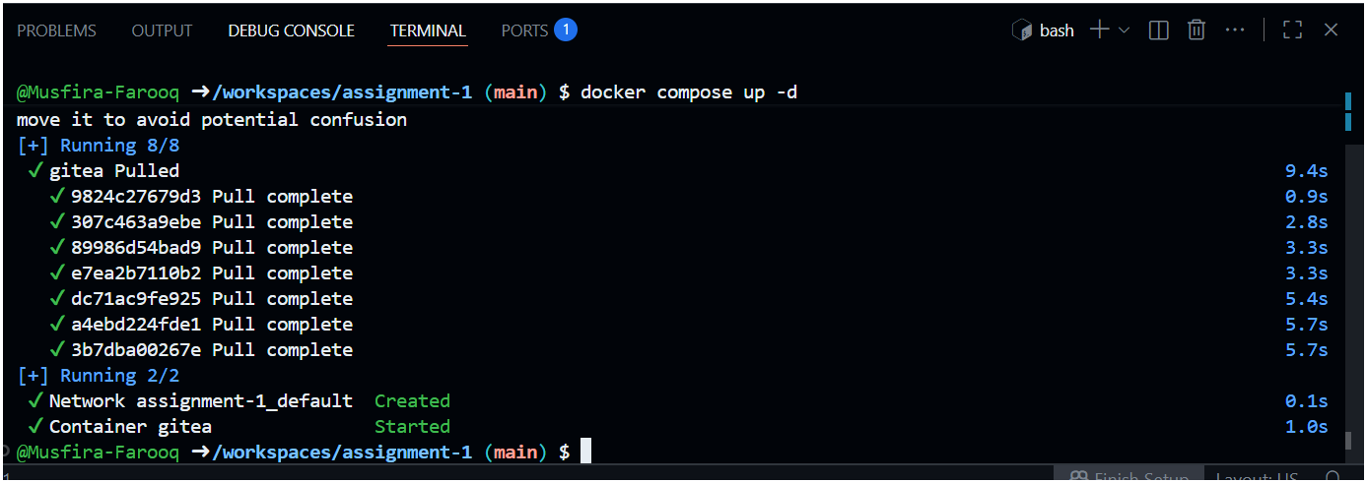

* **Port 3000 web address:**

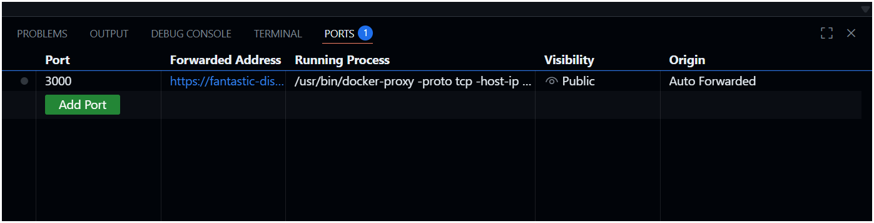

* **Installing Gitea:**

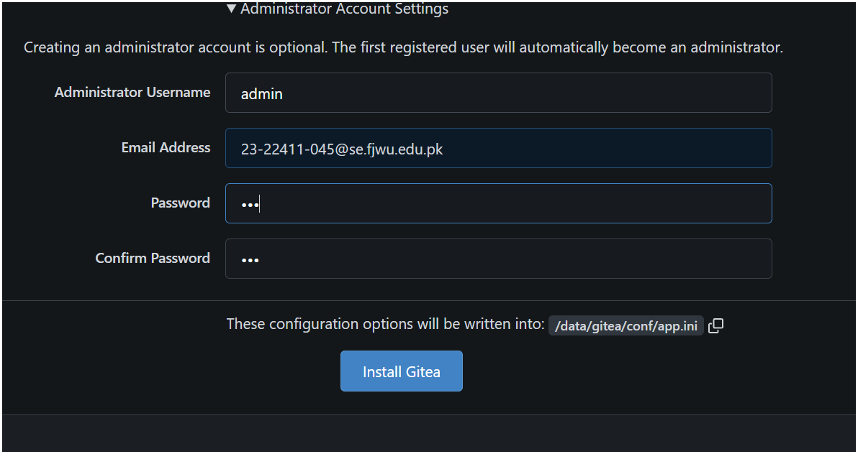

* **Gitea Running in Codespace:**

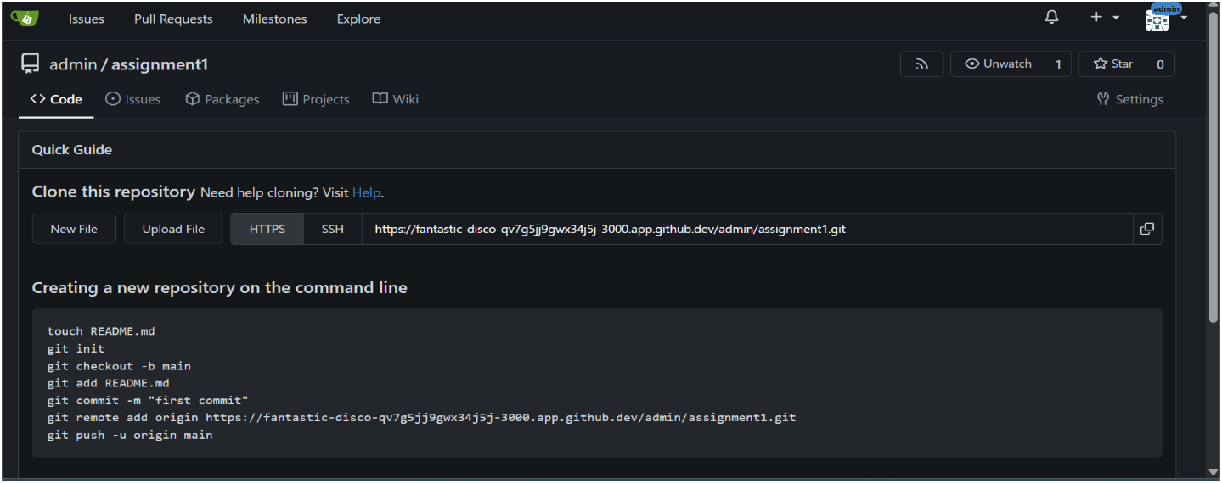

* **Gitea Repository with README.md:**

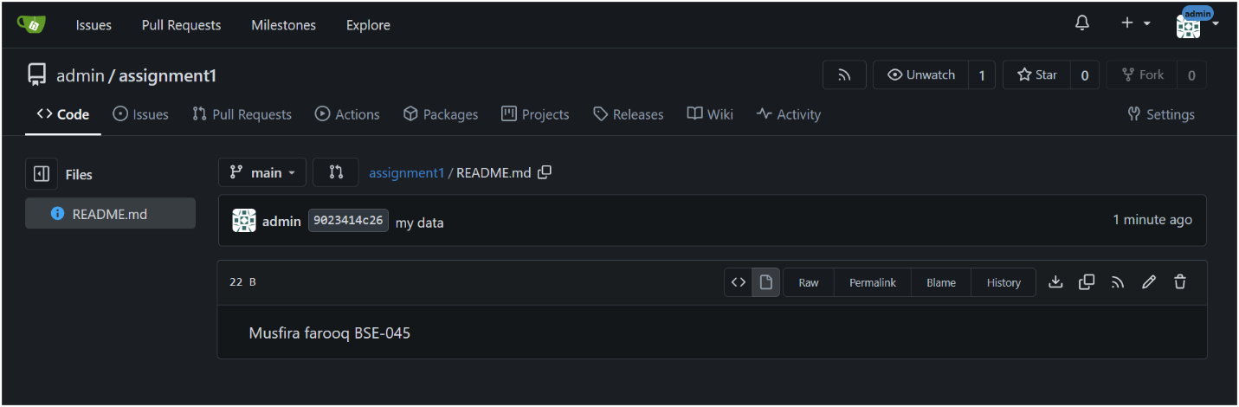

* **Git Remote Command (Gitea Remote Added)**

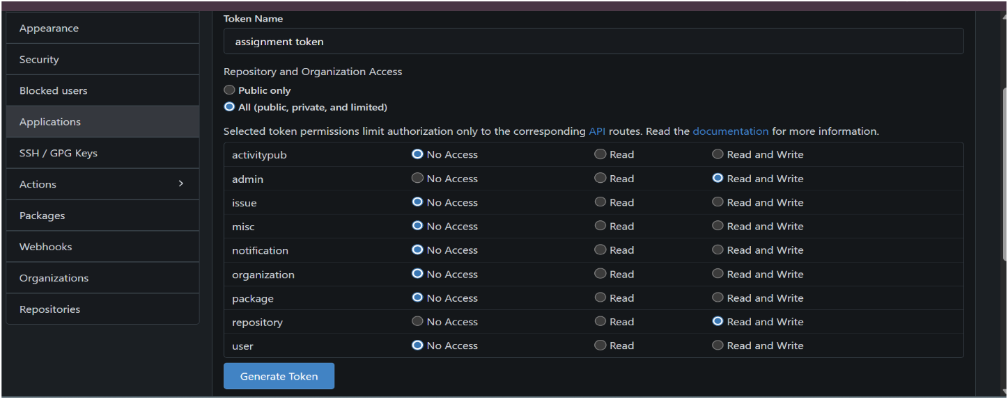

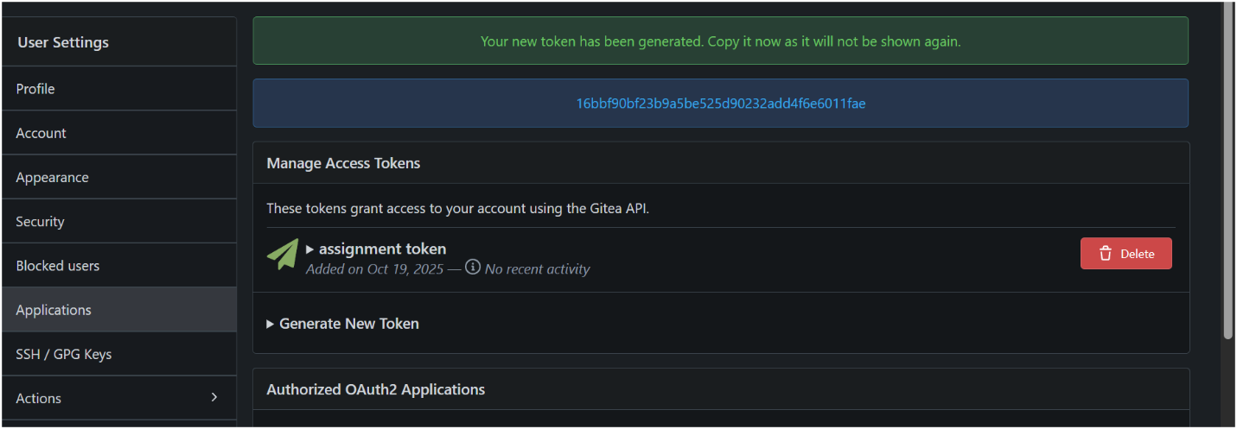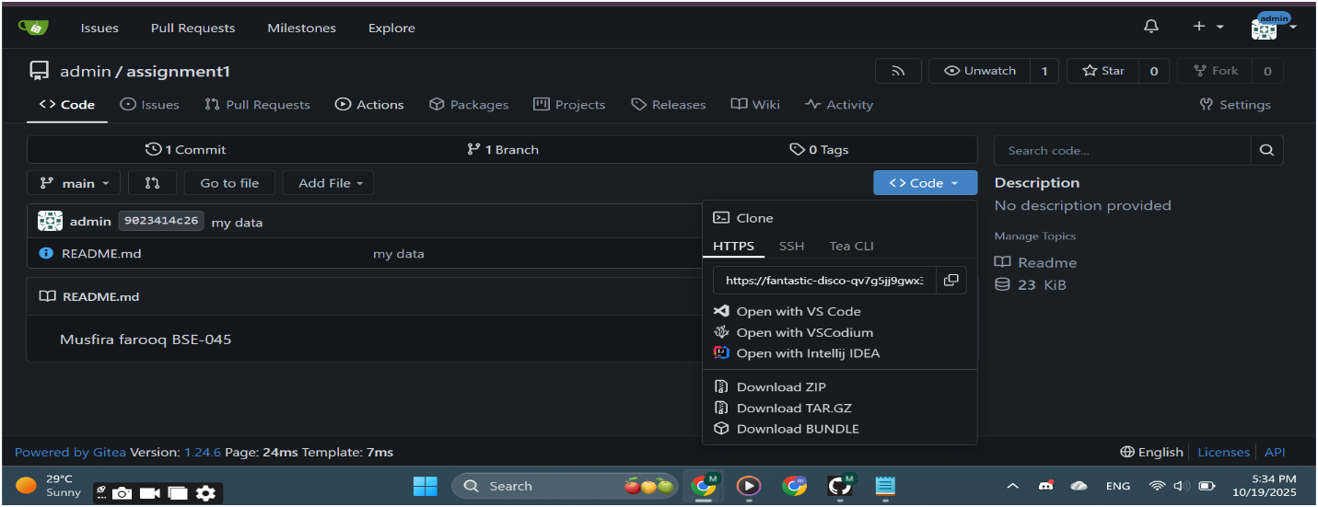

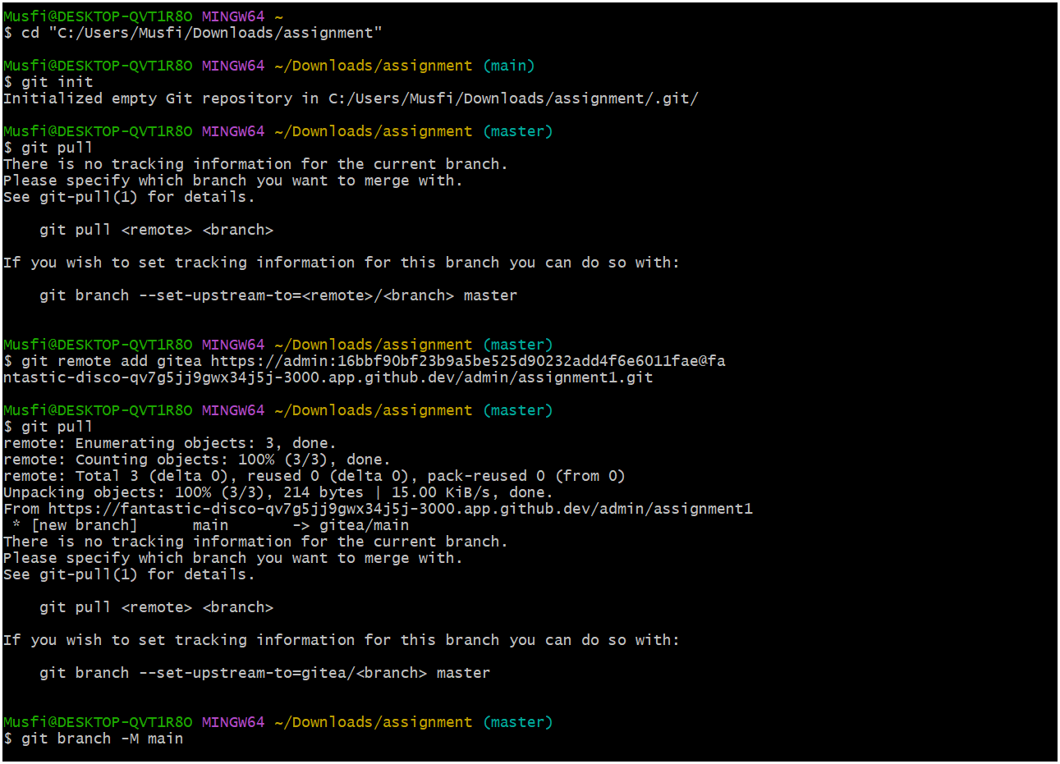

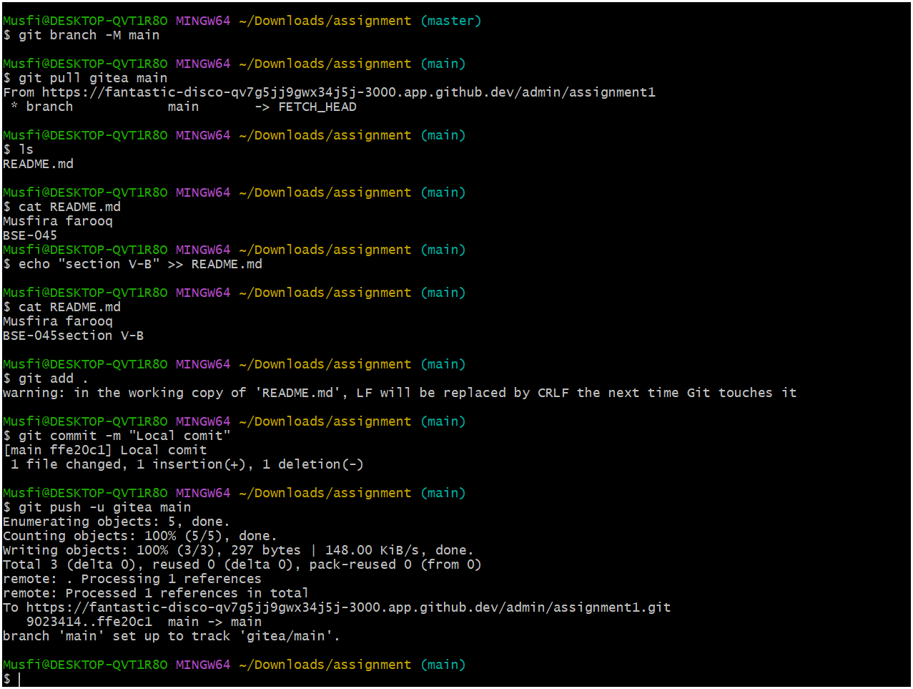

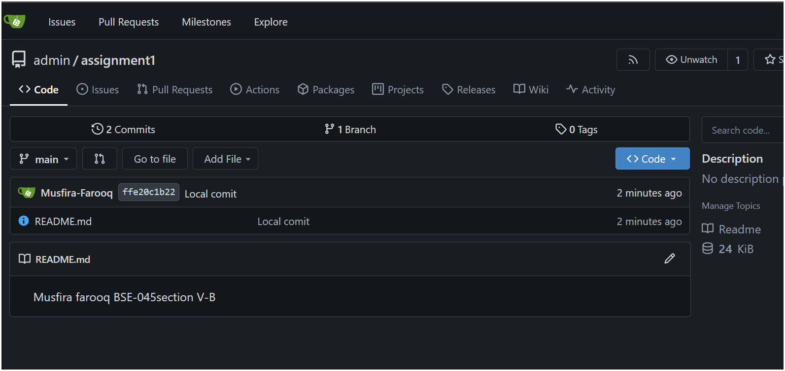

**TASK 02**

**Mirror README.md from Gitea to GitHub**

* **GitHub Repository (assignment-1) with readme.md:**

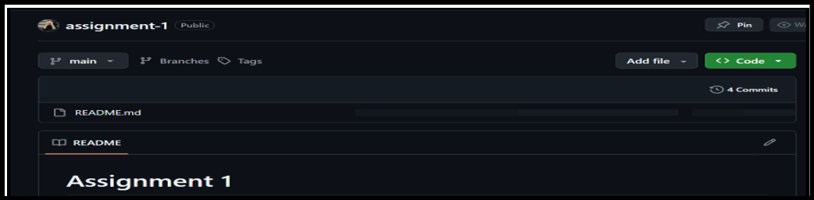

* **Git Remote Command (Both Remotes):**

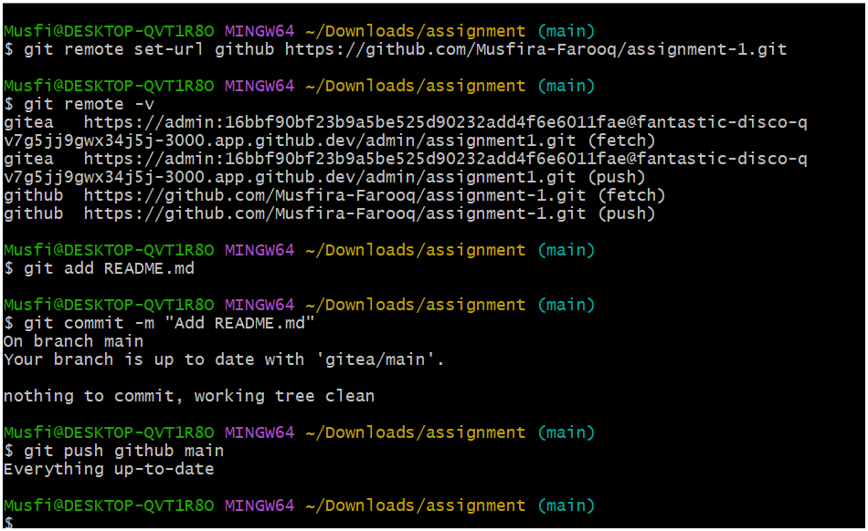

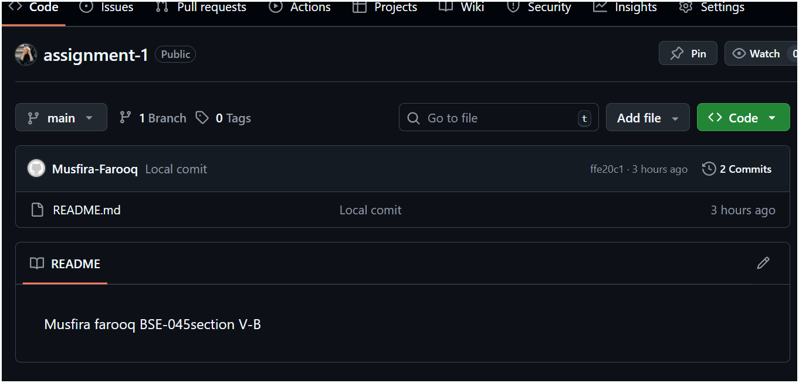

**TASK 03**

**Use Git LFS for Large Files**

* **Git LFS Installation:**

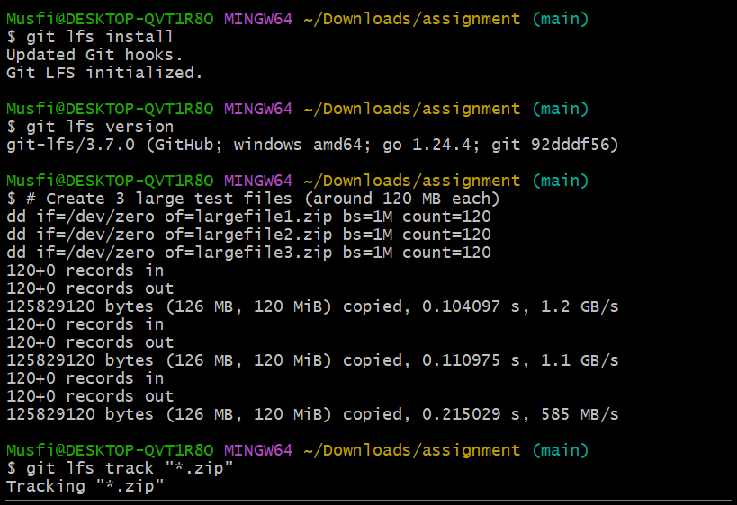

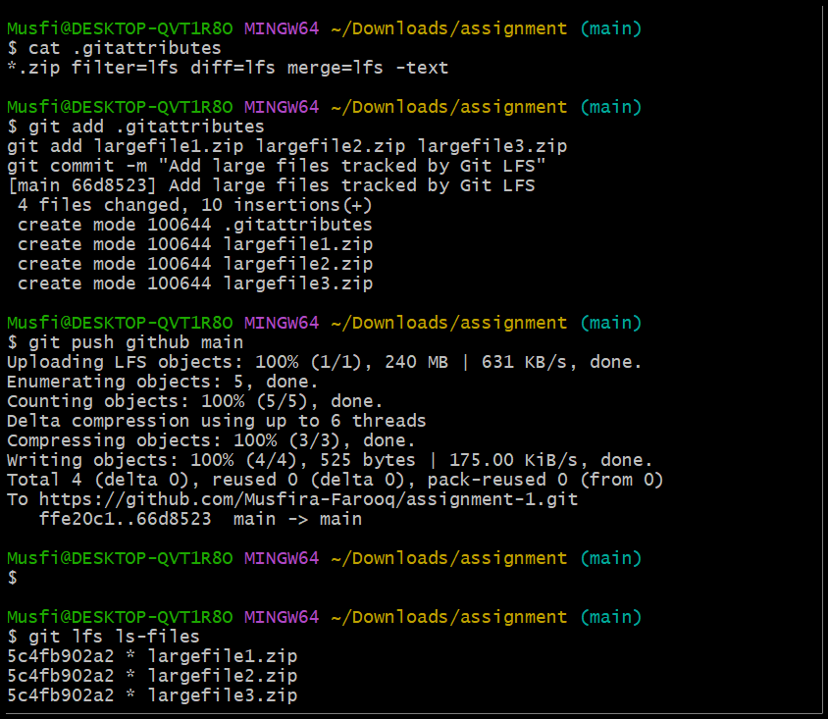

* **GitHub Repository Showing Large Files:**

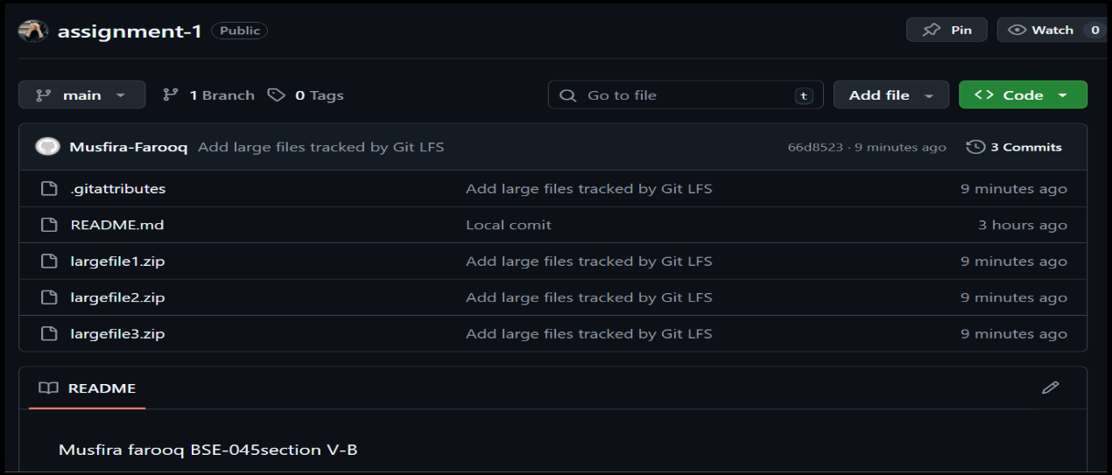

**TASK 04**

**Create a Portfolio/CV with GitHub Pages**

* **GitHub Pages Repository:**

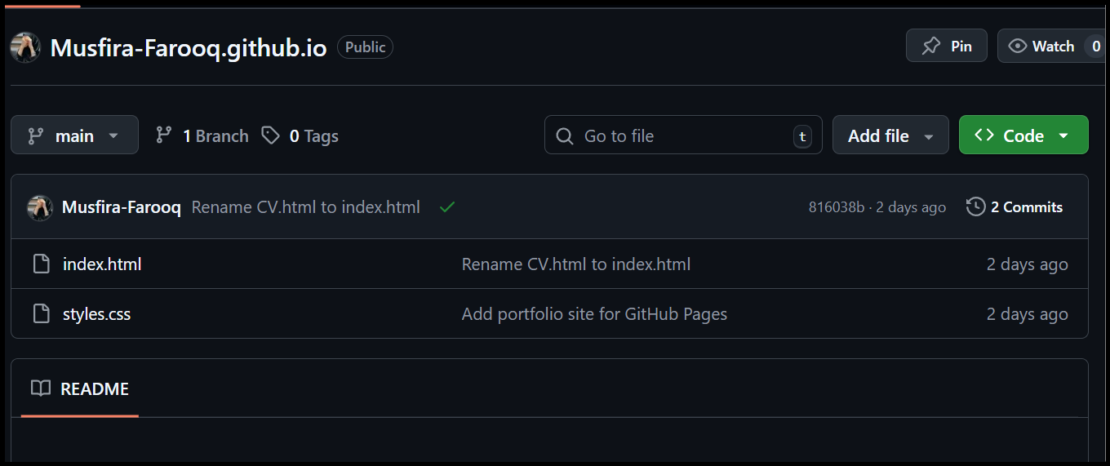

* **GitHub Pages Settings:**

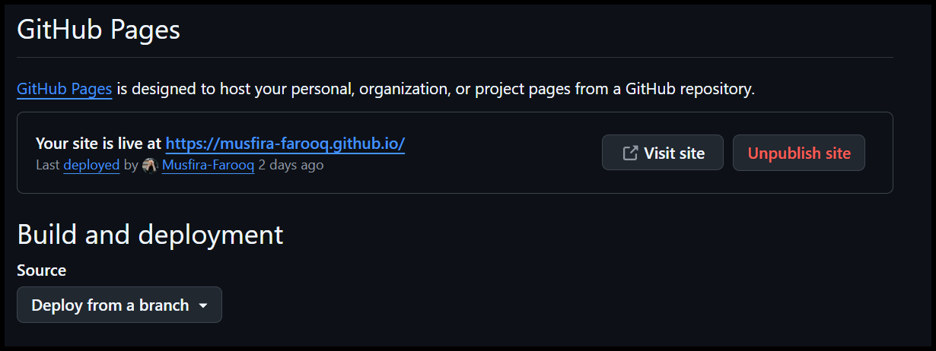

* **Live CV Website:**

[**https://musfira-farooq.github.io/**](https://musfira-farooq.github.io/)

